Usage and Adoption
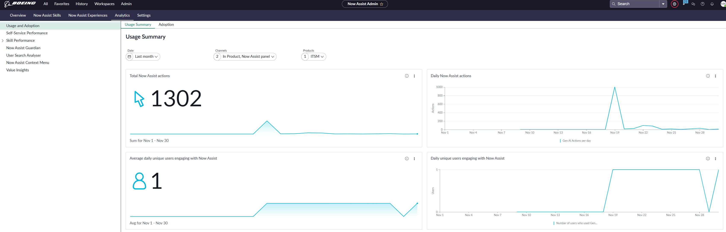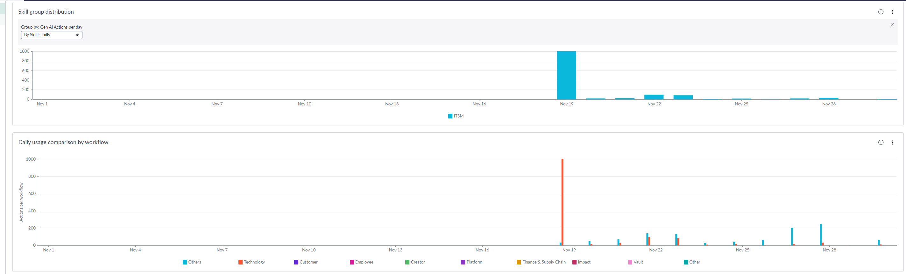

Skill Detail > Chat summarization
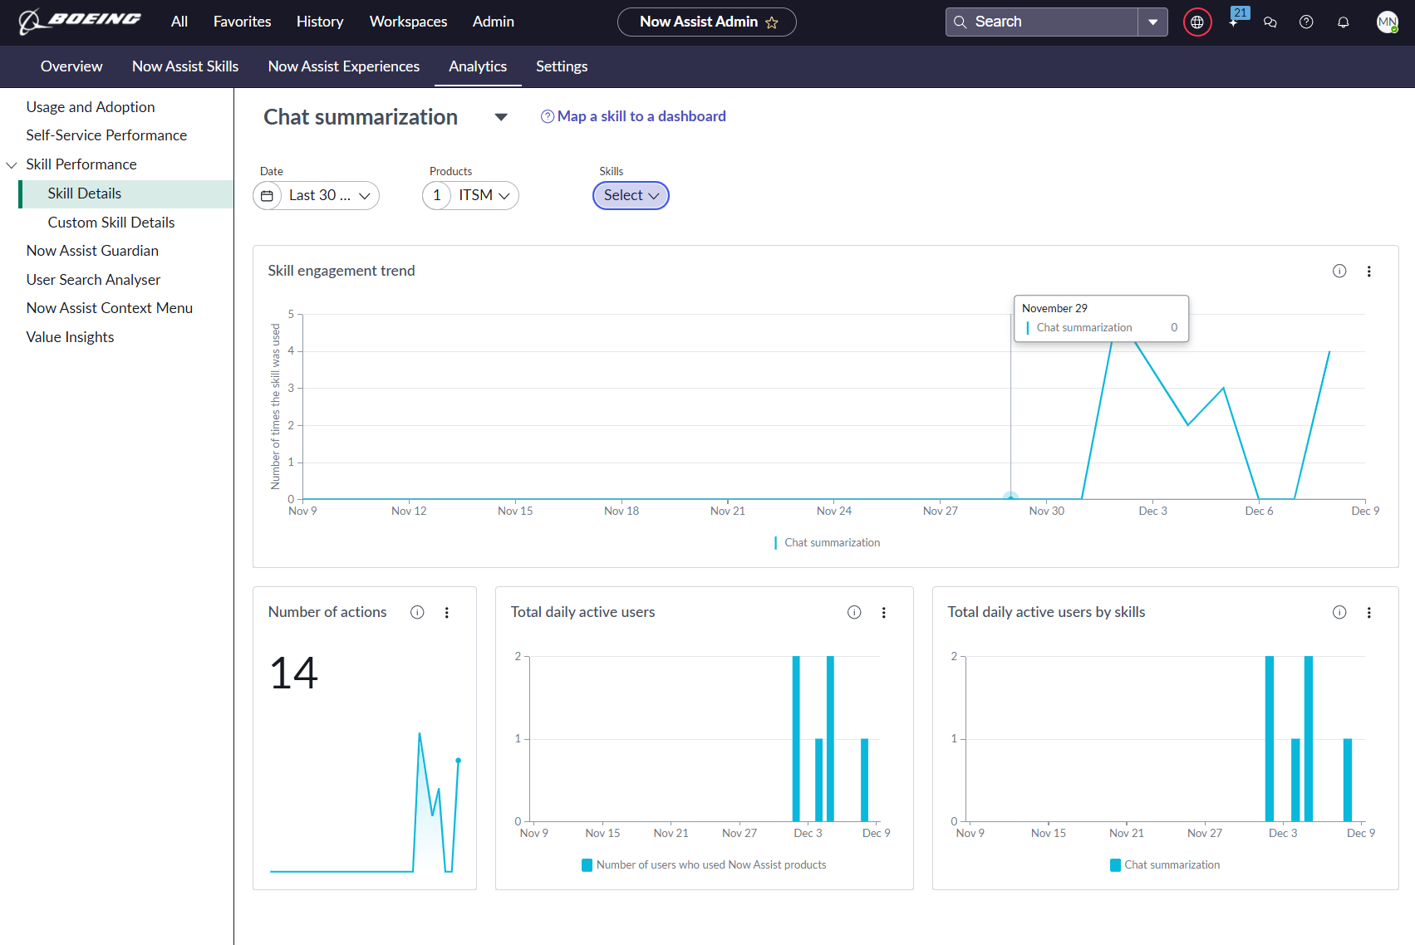

Custom Skills > Sentiment analysis on interaction
